**­**

|  |  |
| --- | --- |
| **Total Marks:** | **7.5** |
| **Obtained Marks:** |  |

**Introduction to Software Development(Lab)**

**(Lab Task 1)**

**Submitted To: Zubair Ahmed**

**______________________________________________________________________________________________________________________________________________________________________________________________________________________________________**

**Student Name: Israr ul haq**

**_______________________________________________________________________________________________________________________________________________________________________________________________________________________________________**

**Reg Number: 1712202**

**_______________________________________________________________________________________________________________________________________________________________________________________________________________________________________**

**Lab Task**

**Employee class:**

**public** **abstract** **class** Employee {

**private** String firstName;

**private** String lastName;

**private** String SSN;

**public** **abstract** **double** earnings();

**public** Employee(String firstName, String lastName, String sSN) {

**super**();

**this**.firstName = firstName;

**this**.lastName = lastName;

SSN = sSN;

}

**public** String getFirstName() {

**return** firstName;

}

**public** **void** setFirstName(String firstName) {

**this**.firstName = firstName;

}

**public** String getLastName() {

**return** lastName;

}

**public** **void** setLastName(String lastName) {

**this**.lastName = lastName;

}

**public** String getSSN() {

**return** SSN;

}

**public** **void** setSSN(String sSN) {

SSN = sSN;

}

@Override

**public** String toString() {

**return** "Employee [firstName=" + firstName + ", lastName=" + lastName + ", SSN=" + SSN + "]";

}

}

**CommisionEmployee Class:**

**public** **class** CommisionEmployee **extends** Employee {

**private** **double** grossSale;

**private** **double** commissionRate;

**public** CommisionEmployee(String firstName, String lastName, String sSN, **double** grossSale, **double** commissionRate) {

**super**(firstName, lastName, sSN);

**this**.grossSale = grossSale;

**this**.commissionRate = commissionRate;

}

**public** **double** getGrossSale() {

**return** grossSale;

}

**public** **void** setGrossSale(**double** grossSale) {

**this**.grossSale = grossSale;

}

**public** **double** getCommissionRate() {

**return** commissionRate;

}

**public** **void** setCommissionRate(**double** commissionRate) {

**this**.commissionRate = commissionRate;

}

@Override

**public** **double** earnings() {

**return** commissionRate * grossSale;

}

@Override

**public** String toString() {

**return** "CommisionEmployee" + grossSale + commissionRate + "Employee" + getFirstName() + getLastName() + getSSN();

}

}

**BasePluseCommisionEmployee Class:**

**public** **class** BasePluseCommisionEmployee **extends** CommisionEmployee {

**private** **double** baseSalary;

**public** BasePluseCommisionEmployee(String firstName, String lastName, String sSN, **double** grossSale,

**double** commissionRate, **double** baseSalary) {

**super**(firstName, lastName, sSN, grossSale, commissionRate);

**this**.baseSalary = baseSalary;

}

**public** **double** getBaseSalary() {

**return** baseSalary;

}

**public** **void** setBaseSalary(**double** baseSalary) {

**this**.baseSalary = baseSalary;

}

@Override

**public** **double** earnings() {

**return** (getCommissionRate()*getGrossSale())+baseSalary;

}

@Override

**public** String toString() {

**return** "BasePluseCommisionEmployee" + baseSalary + "Employee" + getFirstName() + getLastName() + getSSN() +getCommissionRate()+getGrossSale();

}

}

**HourlyEmplyee Class:**

**public** **class** HourlyEmplyee **extends** Employee{

**private** **double** wage;

**private** **double** hours;

**public** HourlyEmplyee(String firstName, String lastName, String sSN, **double** wage, **double** hours) {

**super**(firstName, lastName, sSN);

**this**.wage = wage;

**this**.hours = hours;

}

**public** **double** getWage() {

**return** wage;

}

**public** **void** setWage(**double** wage) {

**this**.wage = wage;

}

**public** **double** getHours() {

**return** hours;

}

**public** **void** setHours(**double** hours) {

**this**.hours = hours;

}

@Override

**public** **double** earnings() {

**double** result=0;

**if** (hours <= 40) {

result = wage * hours;

}

**else** **if**(hours > 40) {

result = 40*wage+(hours-40)*wage*1.5;

}

**return** result;

}

@Override

**public** String toString() {

**return** "HourlyEmplyee" + wage + hours + "Employee" + getFirstName() + getLastName() + getSSN();

}

}

**SalariedEmployee Class:**

**public** **class** SalariedEmployee **extends** Employee {

**private** **double** weeklySalary;

**public** SalariedEmployee(String firstName, String lastName, String sSN, **double** weeklySalary) {

**super**(firstName, lastName, sSN);

**this**.weeklySalary = weeklySalary;

}

**public** **double** getWeeklySalary() {

**return** weeklySalary;

}

**public** **void** setWeeklySalary(**double** weeklySalary) {

**this**.weeklySalary = weeklySalary;

}

@Override

**public** **double** earnings() {

**return** weeklySalary;

}

@Override

**public** String toString() {

**return** "SalariedEmployee" + weeklySalary + "Employee" + getFirstName() + getLastName() + getSSN();

}

}

**Main class:**

**public** **class** PayrollSystemTest {

**public** **static** **void** main( String[] args ) {

SalariedEmployee salariedEmployee = **new** SalariedEmployee( "John", "Smith",

"111-11-1111", 800.00 );

HourlyEmplyee hourlyEmployee = **new** HourlyEmplyee( "Karen", "Price", "222-22-2222", 16.75, 40 );

CommisionEmployee commissionEmployee = **new** CommisionEmployee("Sue","Jones", "333-33-3333", 10000, .06 );

BasePluseCommisionEmployee basePlusCommissionEmployee =**new** BasePluseCommisionEmployee("Bob", "Lewis", "444-44-4444", 5000, .04, 300 );

System.***out***.println( "Employees processed individually:\n" );

System.***out***.printf( "%s\n%s: $%,.2f\n\n",salariedEmployee, "earned",

salariedEmployee.earnings() );

System.***out***.printf( "%s\n%s: $%,.2f\n\n",hourlyEmployee, "earned",

hourlyEmployee.earnings() );

System.***out***.printf( "%s\n%s: $%,.2f\n\n",commissionEmployee, "earned",

commissionEmployee.earnings() );

System.***out***.printf( "%s\n%s: $%,.2f\n\n",basePlusCommissionEmployee,"earned",

basePlusCommissionEmployee.earnings() );

// create four-element Employee array

Employee[] employees = **new** Employee[ 4 ];

employees[0] = **new** HourlyEmplyee( "Israr", "Ulhaq", "221", 1.5, 30 );

employees[1] = **new** CommisionEmployee("Kashi","nazar", "312", 120, .26 );

employees[2] = **new** SalariedEmployee( "Zeshan", "But","1123", 230.20 );

employees[3] =**new** BasePluseCommisionEmployee("Majid", "Khan", "4123", 512, .34, 200 );

System.***out***.println( "Employees processed polymorphically:\n" );

// generically process each element in array employees

**for** ( Employee currentEmployee : employees )

{

System.***out***.println( currentEmployee ); // invokes toString

// determine whether element is a BasePlusCommissionEmployee

**if** ( currentEmployee **instanceof** BasePluseCommisionEmployee ) {

// downcast Employee reference to

// BasePlusCommissionEmployee reference

BasePluseCommisionEmployee employee =( BasePluseCommisionEmployee )

currentEmployee;

employee.setBaseSalary( 1.10 * employee.getBaseSalary() );

System.***out***.printf(

"new base salary with 10%% increase is: $%,.2f\n",

employee.getBaseSalary() );

}

}

}

}

**UML Screen short:**

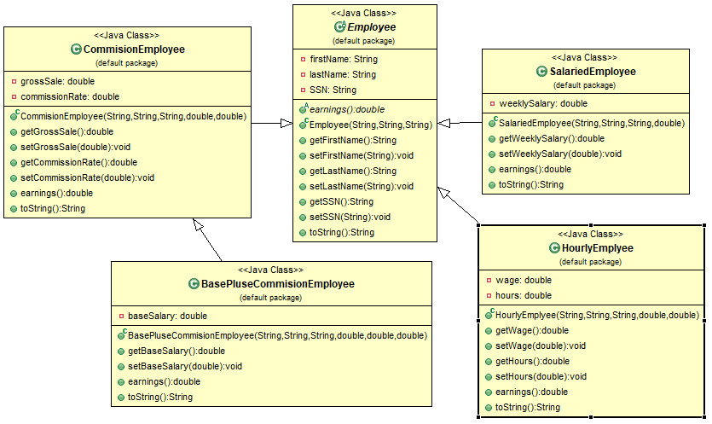

**Screen short:**

